**Experiment No. 2.1**

**Student Name:** GauravKumar   **UID:** 22MCC20177

**Branch:** MCA **-** CCD   **Section/Group:** 22MCD1 **/** GrpA

**Semester:** II  **Date of Performance:** 09th April 2023

**Subject Name:** Advanced Internet Programming Lab **Subject Code:** 22CAP-686

1. **Aim/Overview of the practical:**

**Task to be done:**

1. Connect
2. Create Database
3. Create Table
4. Insert Records into respective table
5. Update records of particular table of database
6. Delete Records from table.
7. Delete table and database
8. **Code for experiment/practical:**

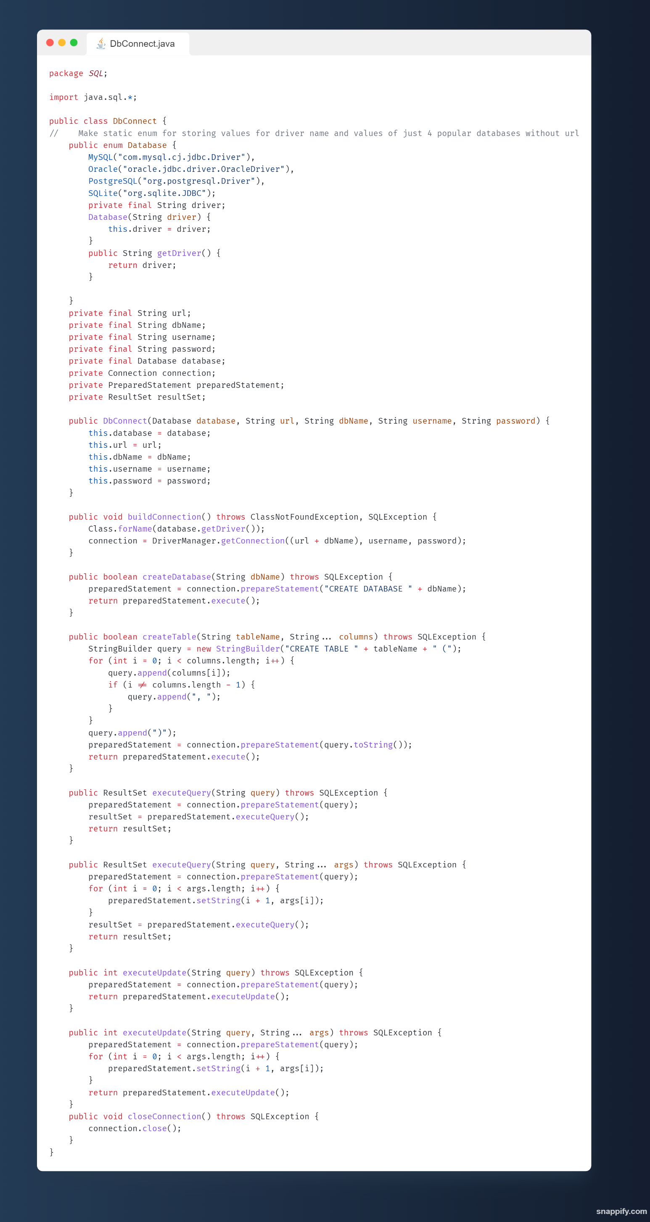

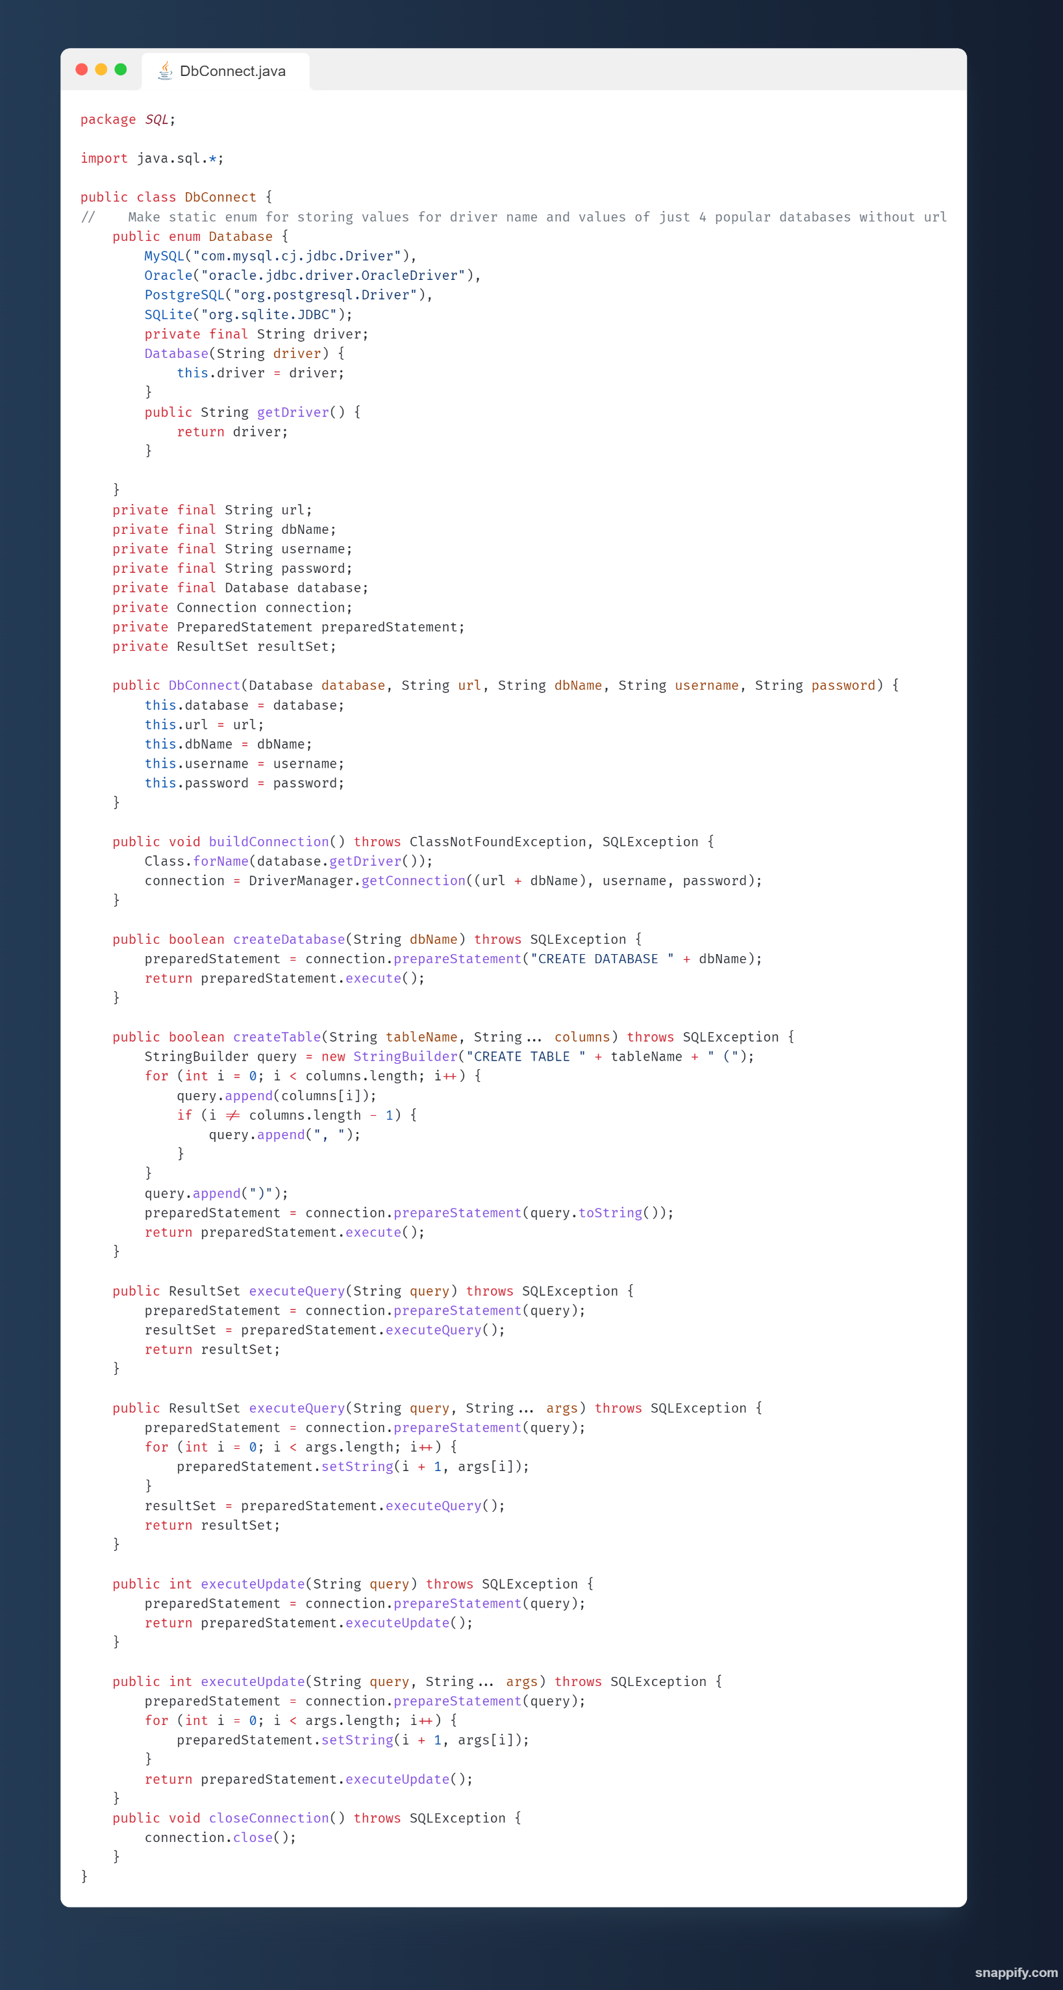

**Learning outcomes (What I have learnt):**

**1. Learn about Database Connectivity JDBC-ODBC.**

**2. Learn about prepareStatement and other functions.**

1. **Evaluation Grid:**

|  |  |  |  |
| --- | --- | --- | --- |
| Sr. No. | Parameters | Marks Obtained | Maximum Marks |
| 1. | Demonstration and Performance (Pre Lab Quiz) |  | 5 |
| 2. | Worksheet |  | 10 |
| 3. | Post Lab Quiz |  | 5 |